A REPORT ON THE TERMINATOR SERIES COMPILED BY STUDENTS OF JKUAT ON 22 ND MARCH, 2023.

# INTRODUCTION.

The terminator series is a compilation of movies which gives a storyline about the war between robots and humans .The series is a science fiction movie whose script writer is Cameron. The first movie in the series was first released in the year 1980 and the last movie released in the year 2019 .

It has come to the attention of the lecturer ,Bob Afuata , that his students need to be informed on the operations of robots . He has requested his students to compile a research on the series , Terminators.

# FINDINGS.

From the research carried out by his students , they were able to deduce a few things concerning the series .These include:

1.In the terminator series there are a number of robots which were designed to kill human beings and protect the Skynet headquarters .

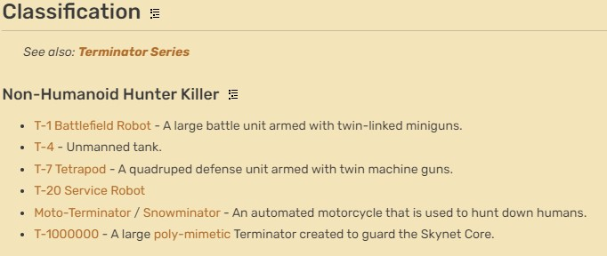

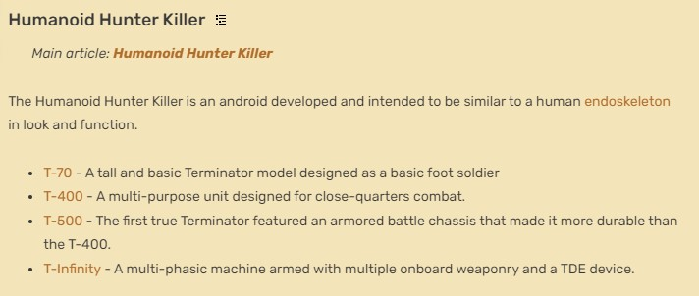

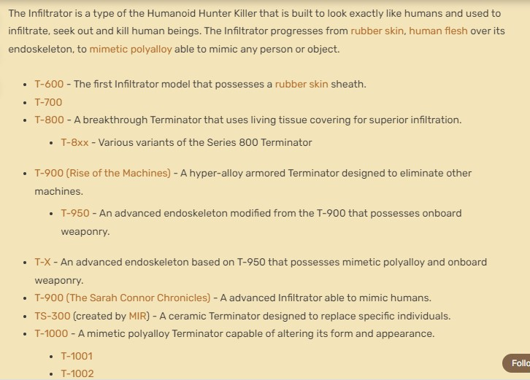

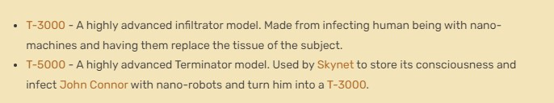

2.The materials from which the terminators were made are coltan , for heat resistance , and titanium. In [*Terminator: The Sarah Connor Chronicles*](https://terminator.fandom.com/wiki/Terminator:_The_Sarah_Connor_Chronicles) timeline, Cameron Phillips establishes that modern Terminators are made of [coltan](https://terminator.fandom.com/wiki/Coltan" \o "Coltan) for heat resistance, while previous models were made of titanium.

3.The company responsible for the creation of the terminators was the Skynet and eventually changed to Legion . Legion changed the way the terminators were being created and made better ones in the Dark fate timeline.

4.The newly made designs as initially stated comprised of an endoskeleton and mimetic polyalloy sheath which enabled them to mimic the actions of human beings. These models were given the name “Rev” and assigned numbers such as Rev-7 and Rev-9 whose model was similar to the T-X model. The materials from these prototypes enabled them to separate and work independently.

5.According to Cameron , most terminators were made of dense alloy which did not allow them to swim in water but could be able to survive under water . Among the robots made , the T-H model exceeds the expectations by having the ability to swim due to its human nature.

6.The dense alloy which was used to make the terminators and the armor coating made them impenetrable to bullets and more durable than most HKs.

7.Unlike human beings ,cyborgs were regarded not to have feeling but in times of extreme heat they perceived it as pain in there data chips.

Below is an orientation of the timeline of the terminator series:

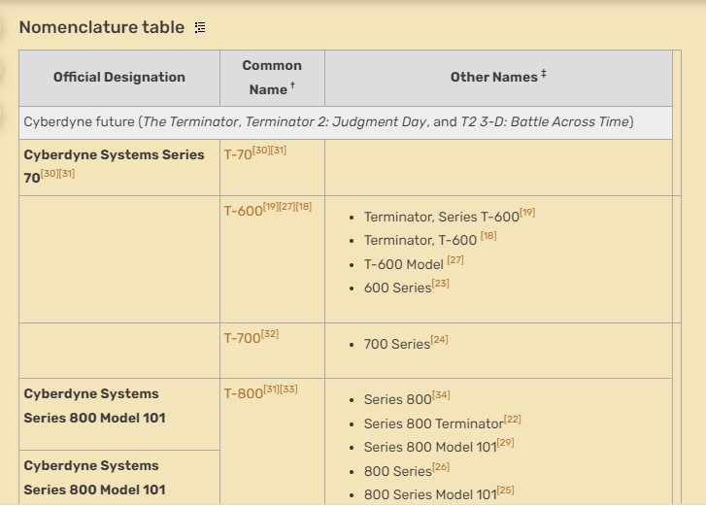

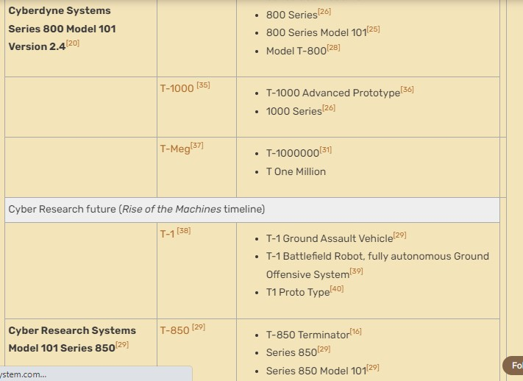

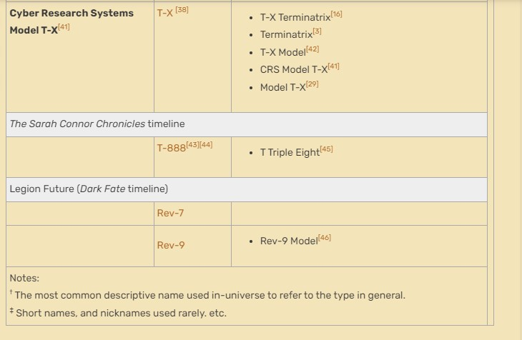

# CONCLUSION.

The creation of the terminators in the terminator series was in order to get rid of the human race which remained and was regarded as an enemy to the Skynet synthetic intelligence and its existence.

# RECOMMENDATION.

The movie was a big hit and despite its release being quite a while ago the movie is a good example of the theories which are going to be implemented in the future. It is highly recommended for people to watch.